**Setting up Application Environment**

**Install IBM Cloud CLI**

|  |  |
| --- | --- |
| Date | 10 NOVEMBER 2022 |
| Batch ID | PNT2022TMID31466 |
| Project Name | Skill/Job Recommender Application |

**Step 1. First login with cloud.ibm.com,→Next search with Container Registry in ibm search catalog**

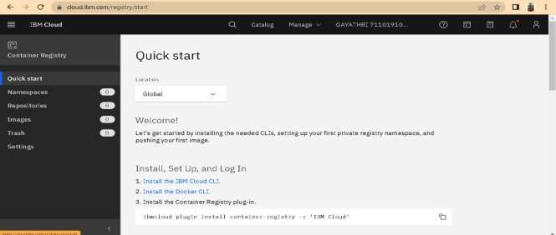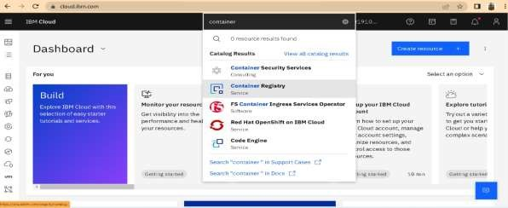

**Step 2 Next click Get started button → Next click Install the IBM Cloud CLI.**

**Step 3: I n cloud CLI there is list of commands insert the into our windows command prompt**

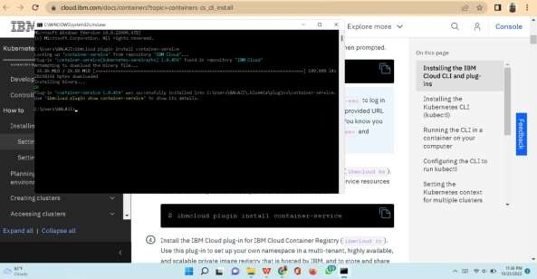

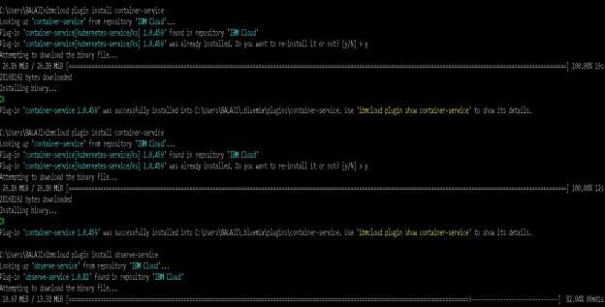

SKILLAND JOB RECOMMENDER PNT2022TMID16882

**STEP 4: After entering all commands the cloud CLI installation is done.**

